

ECL332 COMMUNICATION LAB

SEMESTER VI

DEPARTMENT OF ELECTRONICS AND COMMUNICATION ENGINEERING

TABLE OF CONTENTS

|  |  |  |
| --- | --- | --- |
| **EX.NO** | **EXPERIMENTS** | **PG.NO** |
|  | *PART-A* |  |
| 1 | FM generation and demodulation using PLL | 3 |
| 2 | Generation and Detection of BPSK | 6 |
| 3 | Generation and Detection of Delta modulated signals | 9 |
|  | *PART-B* |  |
| 1 | Error Performance of BPSK | 12 |
| 2 | Error Performance of QPSK | 16 |
| 3 | Performance of Waveform Coding Using PCM | 20 |
| 4 | Pulse Shaping and Matched Filtering | 24 |
| 5 | Eye Diagram | 28 |
|  | *PART-C* |  |
| 6 | Familiarization with Software Defined Radio | 30 |
| 7 | FM Reception | 35 |
| 8 | Familiarization with GNU Radio | 38 |

This PDF document was edited with **Icecream PDF Editor**.

**Upgrade to PRO** to remove watermark.

## 1. FM generation and demodulation using PLL

AIM:To generate frequency modulated signal and to demodulate the Frequency Modulated signal using PLL.

COMPONENTS REQUIRED: ICs 565, resistors, capacitors, function generator, DSO, DC source and bread board.

THEORY:

In FM, frequency of the carrier signal is varied in accordance with the instantaneous amplitude of the modulating signal. PLL is widely used for FM generation. The frequency generated by the VCO of the PLL is varied by the input signal applied. The resistor R1 and capacitor C1  decides the carrier frequency of the FM. AF input is capacitively coupled to pin 7 of the IC using R3-Cc network.

For the demodulation of the FM signal, the center frequency of the VCO of the demodulator is made the same as that of the modulator. The variation of the input frequency from the center frequency is converted into the variation of the voltage by the phase comparator of the demodulator. FM input is coupled to the pin 2 using R3-Cc network as shown in figure.2

Major advantage of FM demodulator using PLL is linearity. Linearity is governed by the voltage to frequency characteristics of the VCO within the PLL. As the frequency deviation of the incoming signal swings over a small portion of the PLL bandwidth, and the characteristics of the VCO can be made relatively linear, the distortion levels from PLL demodulators are normally very low.

**CIRCUIT DIAGRAM:**

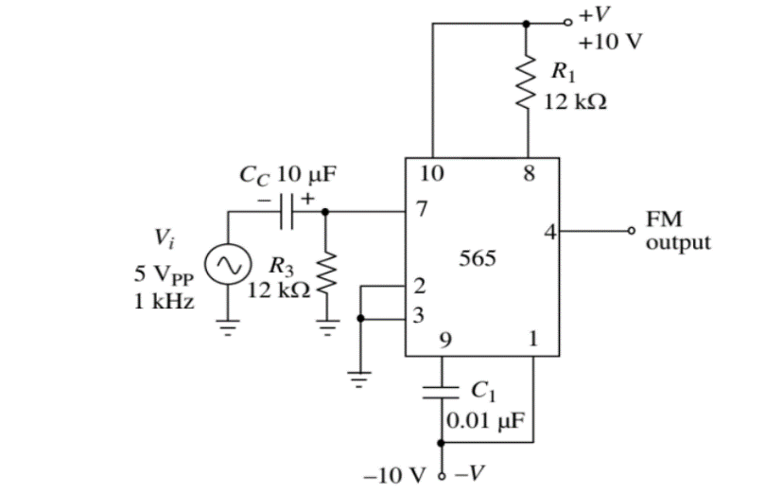

Figure1. FM generation using IC565

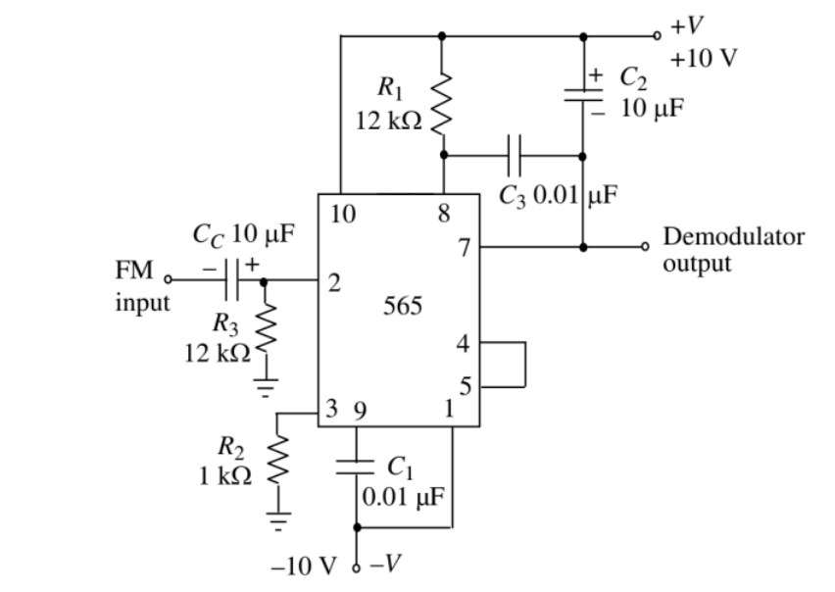

Figure 2. FM Demodulation using IC565

**DESIGN**

Let V+ =10 V and V- = -10

Let the center frequency of the FM be fo=(1.2/4*R1*C1) =2.5 kHz

Take C1=0.01μF Then we get R1=12 kΩ

The value of R1 satisfies the required condition 2 kΩ < R1 < 20 kΩ, as per data sheet. Take Cc=10 μF and R3=12 kΩ to couple the input to the IC.

For demodulator circuit, since center frequency is same as that of modulator, frequency determining components are the same.

Take same set of coupling capacitor and resistor.

Take R2=1 kΩ, C2=10 μF and C3=0.01 μF

**PROCEDURE**

1. Set up the FM generator circuit and apply 5 Vpp, 1KHz sinewave input and observe the output.

2. Note maximum and minimum frequencies, fmax and fmin of FM output. Calculate frequency deviation ∆f= fmax – fmin. Calculate the modulation index mi = ∆f/fm where fm is modulating signal frequency.

3. Set up FM demodulator and apply the FM signal to it. Observe the demodulated output.

**SAMPLE WAVEFORMS**

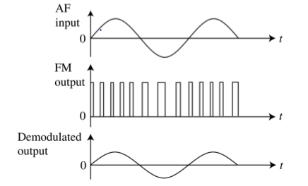

Figure 3: Modulated and demodulated output waveforms.

**RESULT:**

**2 Binary Phase Shift Keying**

**AIM**

To design and set up a BPSK modulator

**COMPONENTS AND EQUIPMENTS REQUIRED**

|  |  |  |
| --- | --- | --- |
| Equipments / Components | Specification / Range | Quantity |
| Resistors  ICs  Transistor  Signal generators  DC supplies  Bread board  CRO |  |  |

**THEORY**

In binary phase shift keying, the binary symbols 1 and 0 modulate the phase of the carrier. Let the carrier signal for transmitting the binary symbol ‘1’ be s1(t)=Acos(2лfct). For the transmission of symbol ‘0’, phase of the carrier is shifted by an amount of 180° (p radians). So s2 (t) = -A cos(2лfct) = A cos(2лfct + л). From the above equations, BPSK signal can be defined as s(t) = b(t) Acos(2лfct), where b(t) = +1 to transmit symbol ‘1’ and b(t) = –1 to transmit symbol ‘0’.

**Modulator**: This circuit mainly consists of a unity gain op-amp inverting amplifier and two switches. Inverting amplifier provides 180° phase-shift to carrier signal s(t). The binary symbols are applied to the control inputs of two switches. An op-amp inverting Zero Crossing Detector (ZCD) enables to apply symbol ‘1’ at the control input of one switch while ‘0’ at the control input of the other switch. BPSK signal has constant amplitude as in the case of BFSK signal. Therefore, the noise can be removed easily.

**Demodulator**: BPSK signal can be demodulated non-coherently by converting it to BASK signal and then by using an envelope detector. The original carrier is added with BPSK signal using a summing amplifier to obtain BASK signal. BASK signal is further demodulated using an envelope detector. The output of the envelope detector may not be square-shaped. Therefore, the demodulated signal is converted to a square-shaped signal with the help of a comparator

**CIRCUIT DIAGRAM**

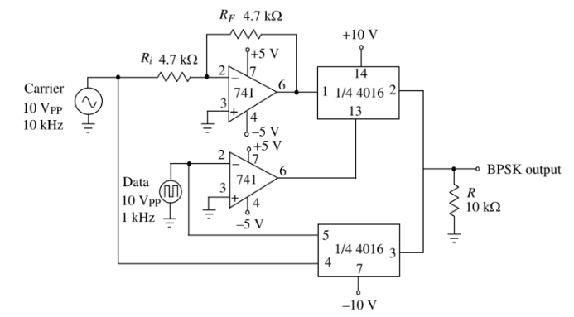

Figure: BPSK Modulator

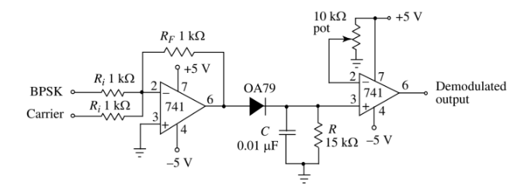

Figure: BPSK Demodulator

**DESIGN**

**Modulator**: Gain of inverting amplifier A= -RF/Ri.

Let the Gain be -1 so that the ratio RF/Ri=1. Take Ri = RF =4.7 kΩ

**Demodulator**: Use 1 kΩ resistor as RF and Ri to get unity gains for the adder circuit. Carrier frequency is 10 kHz and data input frequency are 1kHz.

We know, ƒ= $\frac{1}{2πRC}$ =1 kHz

If C=0.01μF, then R= 15 kΩ

Use a 10kΩ pot for setting the threshold voltage for the comparator.

**WAVEFORMS:**

-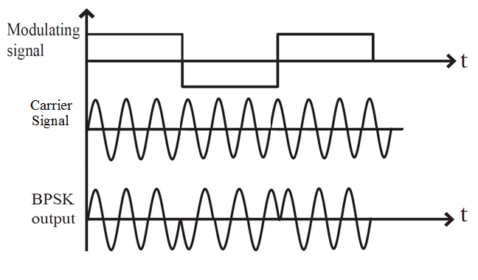

**PROCEDURE:**

1. Setup the circuit part by part and verify their function.
2. Connect the parts together and observe the output waveform on CRO.

**RESULT:**

**3 DELTA MODULATION AND DEMODULATION**

**AIM**

To design, setup and study a Delta Modulator and Demodulator circuit.

**COMPONENTS AND EQUIPMENTS REQUIRED**

|  |  |  |
| --- | --- | --- |
| Equipment / Components | Specification / Range | Quantity |
| Resistors  Capacitors  IC’s  Signal generators  DC Supplies  Bread board  CRO |  |  |

**THEORY**

Delta Modulation (DM) is a differential PCM scheme in which the difference signal is encoded into a single bit. This single bit is transmitted per sample to indicate whether the signal is larger or smaller than the previous sample. The difference between the input and the approximation is quantized into two levels ±∆ corresponding to positive or negative difference respectively. Here in the circuit the modulating signal m(t) and its quantized approximation mˆ(t) are applied to the comparator. Comparator provides a high-level output when m(t) > mˆ(t) and provides low level output when m(t) < mˆ(t). The output of the comparator is fed to a sample and hold circuit made by a D flip flop. Pulses at the output of D flip flop is made bipolar by an op-amp comparator. IC 741 is used as the comparator whose output becomes +5 V when the voltage at its pin 3 is greater than +0.5 V. The demodulator consists of an integrator and a low pass filter

**CIRCUIT DIAGRAM**

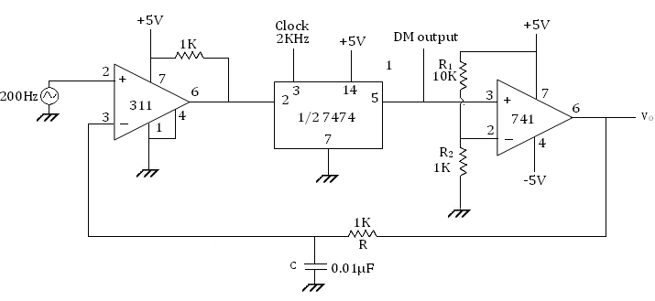

Figure1: Delta modulator

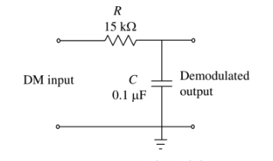

Figure 2: Delta demodulator

**DESIGN**

Let the input signal amplitude be 5V and frequency be 200 Hz.

i.e., m(t) = 5sin400πt

Maximum slope of m(t) = 2πfA = 2π2000 X 5 = 2000 π

To avoid slope overload error, slope of $\overline{m}(t)$ should be more than that of m(t).

$$Vcc/RC>E_{m}ω_{m}$$

Selecting Vcc =15V and C = 0.01 µF, we get $R<228K$. Take R = 100K.

Therefore $\frac{VccR_{2}}{R_{1}+R_{2}}$ = 1.35 V.

Take R2 =1K. Then R1 = 10K.

Let the clock frequency be 2KHz.

**WAVEFORMS:**

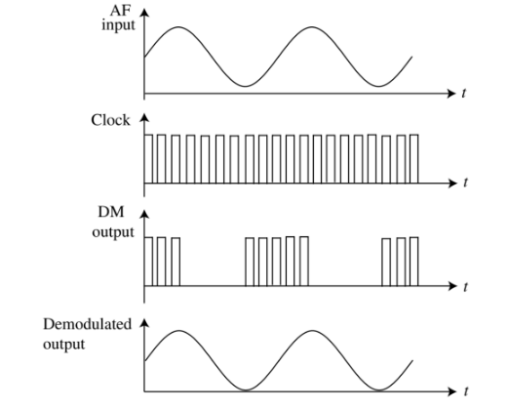

Figure3: Waveforms

**PROCEDURE**

1. Setup the circuit after verifying the components.
2. Feed a unipolar 5V, 200 Hz sine wave to the input using offset knob of function generator. Set the clock frequency at 2KHz.
3. Observe the DM output and Vo simultaneously on CRO.

**RESULT**

**Part B**

**1: Error Performance of Binary Phase Shift Keying**

**AIM**

1. Generate a string of message bits.

2. Encode using BPSK with energy per bit Eb and represent it using points in a signal-space.

3. Simulate transmission of the BPSK modulated signal via an AWGN channel with variance N0/2.

4. Detect using an ML decoder and plot the probability of error as a function of SNR per bit Eb/N0.

**THEORY**

**Binary Phase Shift Keying**

In a coherent binary PSK system, the pair of signals S1(t) and S2 (t) used to represent binary symbols 1 & 0 are defined by

S1 (t) = √2Eb/τb Cos 2πfct

S2 (t) =√2Eb/Tb (2πfct+π) = - √ 2Eb/Tb Cos 2πfct where 0 ≤ t< Tb and

Eb = Transmitted signed energy for bit

The carrier frequency fc **=**n/Tb for some fixed integer n.

In BPSK, there is only one basis function of unit energy.

Øb (t) = √2/Tb cos 2fπct 0≤ t< Tb

S1 (t) = √Eb Ø1 (t) 0≤ t ≤Tb

S2 (t) = √Eb Ø1 (t) 0≤ t< Tb

The signal space is 1dimensional (N=1) having two message points (M = 2)

**Block Diagram of BPSK Transmitter**

The input binary symbols are represented in polar form with symbols 1 & 0 represented by constant amplitude levels √Eb & -√Eb. This binary wave is multiplied by a sinusoidal carrier in a product modulator. The result in a BSPK signal.



**BSPK Receiver**:

The received BPSK signal is applied to a correlator which is also supplied with a locally generated reference signal Ø1 (t). The correlated output is compared with a threshold of zero volts. If x1> 0, the receiver decides in favour of symbol 1. If x1< 0, it decides in favour of symbol 0.

**ALGORITHM**

1. Generate a sequence of random bits of ones and zeros of certain length (***Nsym*** typically set in the order of 10000)
2. Using the constellation points, map the bits to modulated symbols (For example, bit ‘0’ is mapped to amplitude value ***A***, and bit ‘1’ is mapped to amplitude value ***-A***)
3. Compute the total power in the sequence of modulated symbols and add noise for the given ***EbN0*** (SNR) value. The noise added symbols are the received symbols at the receiver.
4. Use thresholding technique, to detect the bits in the receiver. Based on the constellation diagram above, the detector at the receiver has to decide whether the receiver bit is above or below the threshold 0.
5. Compare the detected bits against the transmitted bits and compute the bit error rate (BER).
6. Plot the simulated BER against the SNR values and compare it with the theoretical BER curve for BPSK over AWGN

**MATLAB CODE**

% Demonstration of Eb/N0 Vs BER for BPSK modulation scheme

clear;

clc;

%---------Input Fields------------------------

N=10000000; %Number of input bits

EbN0dB = -6:2:10; % Eb/N0 range in dB for simulation

%---------------------------------------------

data=randn(1,N)>=0; %Generating a uniformly distributed random 1s and 0s

bpskModulated = 2*data-1; %Mapping 0->-1 and 1->1

M=2; %Number of Constellation points M=2^k for BPSK k=1

Rm=log2(M); %Rm=log2(M) for BPSK M=2

Rc=1; %Rc = code rate for a coded system. Since no coding is used Rc=1

BER = zeros(1,length(EbN0dB)); %Place holder for BER values for each Eb/N0

index=1;

for k=EbN0dB,

%-------------------------------------------

%Channel Noise for various Eb/N0

%-------------------------------------------

%Adding noise with variance according to the required Eb/N0

EbN0 = 10.^(k/10); %Converting Eb/N0 dB value to linear scale

noiseSigma = sqrt(1./(2*Rm*Rc*EbN0)); %Standard deviation for AWGN Noise

noise = noiseSigma*randn(1,length(bpskModulated));

received = bpskModulated + noise;

%-------------------------------------------

%Threshold Detector

estimatedBits=(received>=0);

%------------------------------------------

%Bit Error rate Calculation

BER(index) = sum(xor(data,estimatedBits))/length(data);

index=index+1;

end

%Plot commands follows

plotHandle=plot(EbN0dB,log10(BER),'r--');

set(plotHandle,'LineWidth',1.5);

title('SNR per bit (Eb/N0) Vs BER Curve for BPSK Modulation Scheme');

xlabel('SNR per bit (Eb/N0) in dB');

ylabel('Bit Error Rate (BER) in dB');

grid on;

hold on;

theoreticalBER = 0.5*erfc(sqrt(10.^(EbN0dB/10)));

plotHandle=plot(EbN0dB,log10(theoreticalBER),'k*');

set(plotHandle,'LineWidth',1.5);

legend('Simulated','Theoretical');

grid on;

**SAMPLE GRAPH**

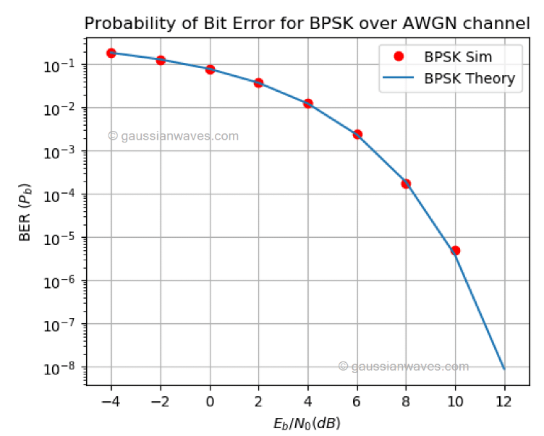

**PYTHON CODE**

#Eb/N0 Vs BER for BPSK over AWGN (complex baseband model)

import numpy as np #for numerical computing

import matplotlib.pyplot as plt #for plotting functions

from scipy.special import erfc #erfc/Q function

#---------Input Fields------------------------

nSym = 10**5 # Number of symbols to transmit

EbN0dBs = np.arange(start=-4,stop = 13, step = 2) # Eb/N0 range in dB for simulation

BER_sim = np.zeros(len(EbN0dBs)) # simulated Bit error rates

M=2 #Number of points in BPSK constellation

m = np.arange(0,M) #all possible input symbols

A = 1; #amplitude

constellation = A*np.cos(m/M*2*np.pi) #reference constellation for BPSK

#------------ Transmitter---------------

inputSyms = np.random.randint(low=0, high = M, size=nSym) #Random 1's and 0's as input to BPSK modulator

s = constellation[inputSyms] #modulated symbols

fig, ax1 = plt.subplots(nrows=1,ncols = 1)

ax1.plot(np.real(constellation),np.imag(constellation),'*')

#----------- Channel --------------

#Compute power in modulatedSyms and add AWGN noise for given SNRs

for j,EbN0dB in enumerate(EbN0dBs):

gamma = 10**(EbN0dB/10) #SNRs to linear scale

P=sum(abs(s)**2)/len(s) #Actual power in the vector

N0=P/gamma # Find the noise spectral density

n = np.sqrt(N0/2)*np.random.standard_normal(s.shape) # computed noise vector

r = s + n # received signal

#-------------- Receiver ------------

detectedSyms = (r <= 0).astype(int) #thresolding at value 0

BER_sim[j] = np.sum(detectedSyms != inputSyms)/nSym #calculate BER

BER_theory = 0.5*erfc(np.sqrt(10**(EbN0dBs/10)))

fig, ax = plt.subplots(nrows=1,ncols = 1)

ax.semilogy(EbN0dBs,BER_sim,color='r',marker='o',linestyle='',label='BPSK Sim')

ax.semilogy(EbN0dBs,BER_theory,marker='',linestyle='-',label='BPSK Theory')

ax.set_xlabel('$E_b/N_0(dB)$');ax.set_ylabel('BER ($P_b$)')

ax.set_title('Probability of Bit Error for BPSK over AWGN channel')

ax.set_xlim(-5,13);ax.grid(True);

ax.legend();plt.show()

**2: Error Performance of QPSK**

**AIM**

1. Generate a string of message bits.

2. Encode using QPSK with energy per symbol Es and represent it using points in a signal-space.

3. Simulate transmission of the QPSK modulated signal via an AWGN channel with variance N0/2 in both I-channel and Q-channel.

4. Detect using an ML decoder and plot the probability of error as a function of SNR per bit Eb/N0 where Es = 2Eb.

**THEORY**

**Quadrature Phase Shift Keying**

Phase of the carrier takes on one of four equally spaced values such as π/4, 3π/4,

5π/4,7π/4.

Si(t) = √2E/ Tb cos {2 πƒct + (2i – 1) π/4} , 0≤ t ≤ Tb

0 , elsewhere

Where i = 1,2,3,4, & E= Tx signal energy per symbol

Tb = symbol duration

Each of the possible value of phase corresponds to a pair of bits called dibits.

Thus the gray encoded set of dibits: 10,00,01,11

Si (t) = √2E/ Tb cos [(2i – 1)π/4] cos (2πfct) - √2E/ Tb sin [(2i –1) π/4)]

sin (2πfct) ,0≤ t ≤Tb 0 , else where

There are two orthonormal basis functions

Ø1 (t) = √2/ Tb cos 2πƒct, 0≤ t ≤Tb

Ø2 (t) = √2/ Tb sin 2πƒct, 0≤ t ≤Tb

**There are four message points**

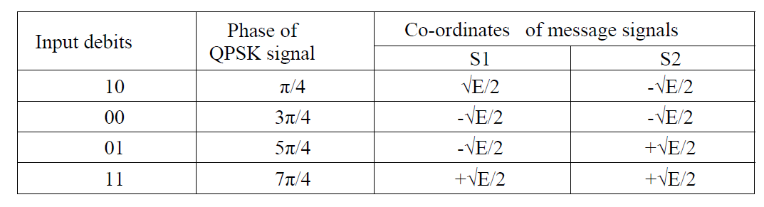

**QPSK Transmitter**



The i/p binary sequence b(t) is represented in polar from with symbols 1 & 0 represented as +√E/2 and -√E/2 .This binary wave is demultiplexed into two separate binary waves consisting of odd & even numbered I/P bits denoted by b1(t) & b2 (t). b1 (t) & b2(t) are used to modulate a pair of quadrature carrier or orthogonal Basis function Ø1 (t) & Ø2 (t). The result is two PSK waves’ .These two binary PSK waves are added to produce the desired QPSK signal .

**QPSK Receiver**



QPSK receiver consists of a pair of correlators with common I/P & supplied with Locally generated Signal Ø1 (t) & Ø2 (t). The correlator O/P, x1, & x2 are each compared with a threshold of zero volts.If x1 > 0, decision is made in favour of symbol ‘1’ for upper channel and if x1 > 0, decision is made in favour of symbol 0. Parallelly Y x2 >0, decision is made in favour of symbol 1 for lower channel & if x2 <0, decision is made in favour of symbol 0. These two channels are combined in a multiplexer to get the original binary output.

**ALGORITHM**

**QPSK Modulation**

1. Generate two carrier signals (Ø1 (t) = √2/Tb cos 2πƒct and Ø2 (t) = √2/Tb cos2πƒct)

2. Generate the base band data signal .

3. Binary wave is divided into odd(b1(t)) and even(b2(t)) numbered input bits.

4. Multiply the odd numbered data signal (b1(t)) and carrier signal 1 in one channel .

5. Multiply the even numbered data signal b2 (t)and carrier signal 2in another channel

6. Sum the output resultant signals of step 4 and 5.

7. The resultant signal is a QPSK signal

8. Plot the carrier, data and QPSK signal.

**QPSK Demodulation**

1. Multiply the received QPSK signal with the carrier signal Ø1 (t) = √2/Tb cos 2πƒct in

one channel and integrate the resultant signal(x1)

2. Multiply the received QPSK signal with the carrier signal Ø2 (t) =√2/Tb cos 2πƒ ct in

another channel and integrate the resultant signal(x2)

3. If x1 is greater than zero then choose 1 and if it is less than 0 choose 0.

4. If x1 is greater than zero then choose 1 and if it is less than 0 choose 0

5. Multiply the resultant signal from step 3 and 4.

6. Plot the demodulated signal.

**MATLAB CODE**

% QPSK MODULATION AND BER ESTIMATION IN AWGN CHANNEL

clc; clear all; close all;

N=1e6; % Number of bits transmited

SNRdB= 0:1:20; % SNR for simulation

SNRlin=10.^(SNRdB/10);

BER = zeros(1,length(SNRlin));% simulated BER

SER = zeros(1,length(SNRlin));% simulated SER

b1 = rand(1,N) > 0.5;

b2 = rand(1,N) > 0.5;

% QPSK symbol mapping

I = (2*b1) - 1;

Q = (2*b2) - 1;

S = I + 1j*Q;

N0 = 1./SNRlin; % Variance

for k = 1:length(SNRdB)

noise = sqrt(N0(k)/2)*(randn(1,N) + 1j*randn(1,N)); % AWGN noise

sig_Rx = S + noise; % Recived signal

% For BER calculation

sig_I = real(sig_Rx); % I component

sig_Q = imag(sig_Rx); % Q component

bld_I = sig_I > 0; % I decision

bld_Q = sig_Q > 0; % Q decision

b1_error = (bld_I ~= b1); % Inphase bit error

b2_error = (bld_Q ~= b2); % Quadrature bit error

Error_bit = sum(b1_error) + sum(b2_error); % Total bit error

BER(k) = sum(Error_bit)/(2*N); % Simulated BER

% For SER calculation

error_symbol = or(b1_error, b2_error); % if bit in I or bit in Q either wrong than error

SER(k) = sum(error_symbol)/N;

end

BER_theo = 2*qfunc(sqrt(2*SNRlin)); % Theoretical BER

SER_theo = 2*qfunc(sqrt(2*SNRlin)) - (qfunc(sqrt(2*SNRlin))).^2; % Theoretical SER

figure(1);

semilogy(SNRdB, BER_theo,'r-')

hold on

semilogy(SNRdB, BER,'k*')

xlabel('SNR[dB]')

ylabel('Bit Error Rate');

legend('Theoretical', 'Simulated');

title(['Probability of Bit Error for QPSK Modulation']);

grid on;

hold off;

figure(2);

semilogy(SNRdB, SER_theo,'r-')

hold on

semilogy(SNRdB, SER,'k*')

xlabel('SNR[dB]')

ylabel('Symbol Error Rate');

legend('Theoretical', 'Simulated');

title(['Probability of symbol Error for QPSK Modulation']);

grid on;

hold off;

**SAMPLE GRAPH**

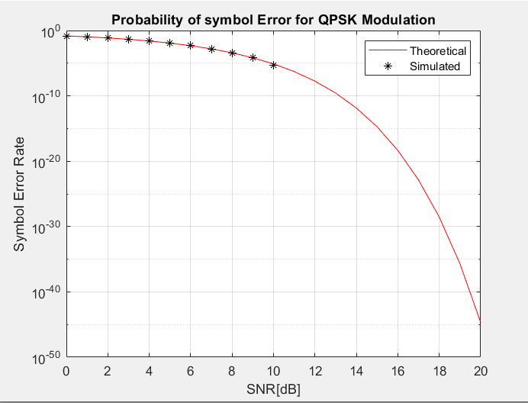

**3 Performance of Waveform Coding Using PCM**

**AIM**

1. Generate a sinusoidal waveform with a DC offset so that it takes only positive amplitude value.

2. Sample and quantize the signal using an uniform quantizer with number of representation levels L. Vary L. Represent each value using decimal to binary encoder.

3. Compute the signal-to-noise ratio in dB.

4. Plot the SNR versus number of bits per symbol. Observe that the SNR increases linearly.

**THEORY**

In Pulse code modulation (PCM) only certain discrete values are allowed for the modulating signals. The modulating signal is sampled, as in other forms of pulse modulation. But any sample falling within a specified range of values is assigned a discrete value. Each value is assigned a pattern of pulses and the signal transmitted by means of this code. The electronic circuit that produces the coded pulse train from the modulating waveform is termed a coder or encoder. A suitable decoder must be used at the receiver in order to extract the original information from the transmitted pulse train.

**ALGORITHM:**

1. Generate a sinusoidal signal with a DC offset of 2.
2. Sample the generated signal.
3. Pass the sampled signal through a quantizer with quantization level=8
4. Encode the signal.
5. Calculate the quantization error and SNR.
6. Vary L and plot the SNR versus number of bits per symbol.

**MATLAB CODE**

% Generate a sinusoidal waveform with a DC offset so that it takes only positive amplitude value clear;% clearing the variables

close all;% closing any opened figures

% Plotting the offset sinusoidal signal time = 0:.0005:.05;

freq_msg=100; %wave form frequency dc_ofst=2; % signal offset

signal=sin(2*pi*freq_msg*time)+dc_ofst; %Generating the signal

% plotting the signal figure;plot(time,signal) xlabel('time') ylabel('Amplitude') title('Signal')

% Sampling the signal freq_sample=15*freq_msg; % sampling frequency

samp_time=0:1/freq_sample:0.05; % sampling time samp_signal=dc_ofst+sin(2*pi*freq_msg*samp_time);% generating the sampled signal

hold on

plot(samp_time,samp_signal,'rx') % plotting the sampled signal title('Sampled Signal')

legend('Original signal','Sampled signal');

% Uniform Quantizer

L=8; %No of Quantization levels smin=round(min(signal)); smax=round(max(signal));

Quant_levl=linspace(smin,smax,L); % Length 8, to represent 9 intervals

codebook = linspace(0,smax,L+1); % Length 9, one entry for each interval

[index,quants] = quantiz(samp_signal,Quant_levl,codebook); % Quantize.

figure;plot(samp_time,samp_signal,'x',samp_time,quants,'.-')% plotting sampled signal and quantization level title('Quantized Signal')

legend('Original signal','Quantized signal'); figure;plot(samp_time,index,'.-')% plotting quantization levels of input signal

title('Encoded Signal')

% Binary coding

for i=1:length(index) bincode_sig{i}=dec2bin(round(index(i)),7);

end

disp('binary encoded signal') disp(bincode_sig')

% SNR ratio calculation

noise=quants-samp_signal; % calculating noise figure;plot(samp_time,noise,'.-') % plotting figure title('Noise')

r=snr(index,noise);% SNR snr1=['SNR:',num2str(r)]; disp(snr1)

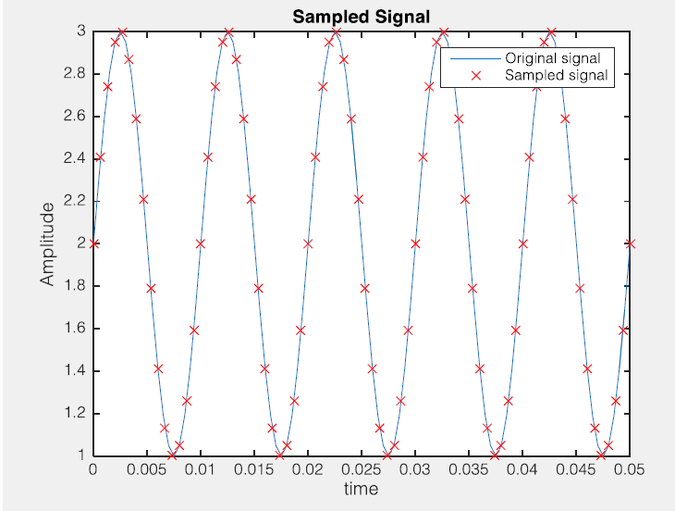

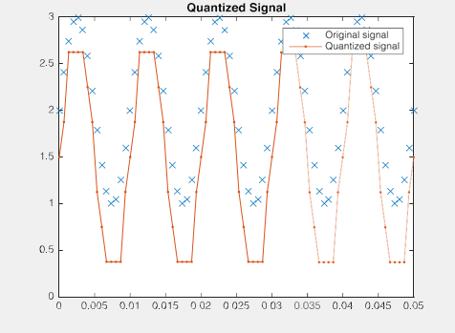

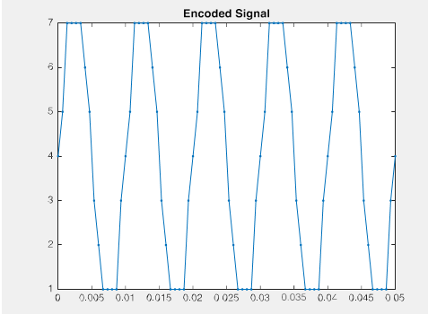

% function for ploting Quant_level vs SNR function [ r ] = IMPL_Quant( l )

% Plotting the offset sinusoidal signal time = 0:.0005:.05;

freq_msg=100; %wave form frequency dc_ofst=2; % signal offset

signal=sin(2*pi*freq_msg*time)+dc_ofst; %Generating the signal

% Sampling the signal freq_sample=15*freq_msg; % sampling frequency

samp_time=0:1/freq_sample:0.05; % sampling time samp_signal=dc_ofst+sin(2*pi*freq_msg*samp_time);%

generating the sampled signal

% Uniform Quantizer

L=l; %No of Quantization levels smin=round(min(signal)); smax=round(max(signal));

Quant_levl=linspace(smin,smax,L); % Length 8, to represent

9 intervals

codebook = linspace(0.7,smax,L+1); % Length 9, one entry for each interval

[index,quants] = quantiz(samp_signal,Quant_levl,codebook);

% Quantize.

% Binary coding

for i=1:length(quants) bincode_sig{i}=dec2bin(round(quants(i)),3);

end

% SNR ratio calculation

noise=quants-samp_signal; % calculating noise r=snr(index,noise);% SNR

end

l=[8,16,32,64,128];% defining different levels for i=1:length(l)

r(i) = IMPL_Quant(l(i));% calling the function

end

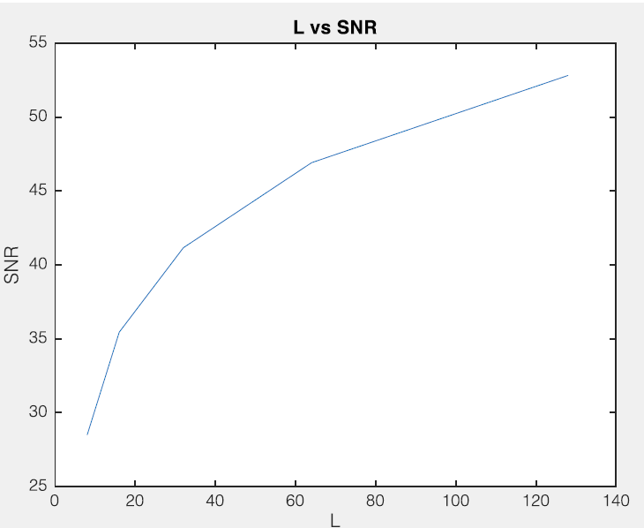

**4.PULSE SHAPING AND MATCHED FILTERING**

AIM:

1. Generate a string of message bits.

2. Use root rasied cosine pulse p(t) as the shapig pulse, and generate the corresponding baseband signal with a fixed bit duration Tb. You may use roll-off factor as α = 0.4.

3. Simulate transmission of baseband signal via an AWGN channel

4. Apply matched filter with frequency response Pr(f ) = P ∗(f ) to the received signal.

5. Sample the signal at mTb and compare it against the message sequence.

THEORY:

***Pulse Shaping***

In communications, digital signals need to be mapped to an analog waveform in order to be transmitted over the channel. The mapping process is accomplished in two steps: (i) Mapping from source bits to complex symbols (also known as constellation points) (ii) Mapping from complex symbols to analog pulse trains(which is used here).

In our pulse shaping scheme, we introduce a set of complex-valued symbols as the input. These symbols are mapped from a bit stream via digital modulation. The bit stream may represent any data format (e.g., text, image, voice, video, etc). These complex-valued symbols are passed through the pulse shaping filter. A representation of this process is shown in Fig.1 below.

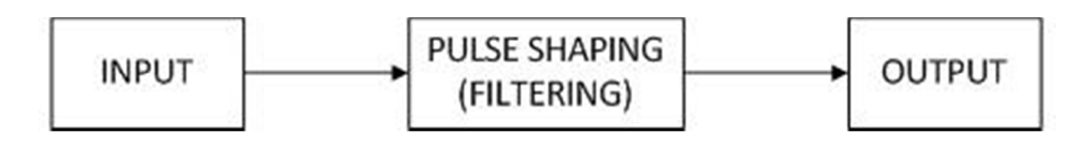

Fig.1 A representation of the pulse shaping process.

Pulse shaping filter must be chosen carefully not to introduce inter-symbol interference. Here we will be using raised cosine filter for pulse shaping.

*Raised-cosine pulse*: This is a pulse widely used in practice. The pulse shape and the excess bandwidth can be controlled by changing the roll-off factor (0≤α≤1, where 0 means no excess bandwidth, and 1 means maximum excess bandwidth). The frequency responses of raised-cosine pulses with different roll-off factors are shown in Fig. 2 below:

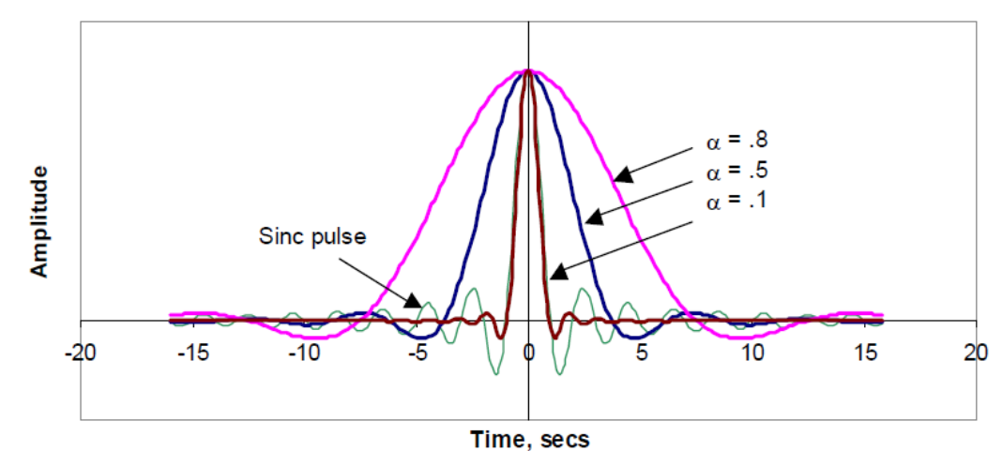

Fig. 2 Frequency response of a raised-cosine filter with different roll-off factor

*Root raised-cosine pulse (RRC):* The total effective filter of the transmission system

is the combination of transmit and receive filter 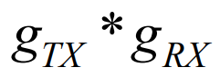 , where ∗ is convolution. This effective filter (and not the individual filters) must fulfil the Nyquist criterion. We can achieve this goal if both filters have a transfer function that is equal to the square root of that of the raised cosine filter. Such a filter is therefore called a root raised cosine (RRC). The combination of both RRC filters then becomes a raised cosine and thus fulfils the Nyquist criterion. Furthermore, since the filters are real-valued and symmetric, the RRC is its own matched filter. The impulse response of

the RRC filter is given as

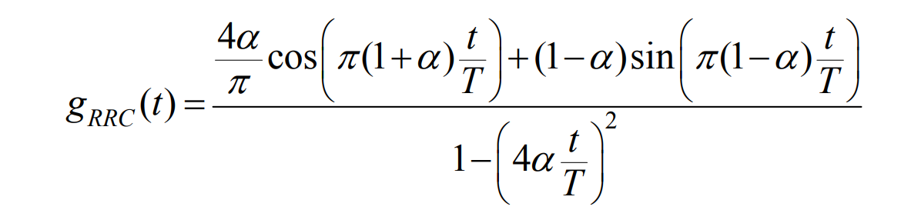

***Matched Filtering***

The receiver’s RF front-end receives analog pulse trains. The information bits need to be recovered from these pulse trains. This is accomplished in two steps: (i) Mapping from analog pulse trains to constellation points. (ii) Mapping from complex symbols to bits, which is Detection.

The received analog signals are matched filtered to create the output complex waveform. Then the samples are detected. A representation of this process is shown in Fig.3 below.

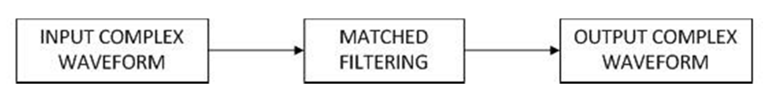

Fig. 3 – A representation of the matched filtering process

*Matched filter design*: A matched filter maximizes the signal to noise ratio (SNR) at its output. Characteristic of the matched filter at the receiver should be complex conjugate of the one at the transmitter in order to fulfill Nyquist criteria. If an RRC filter used at the transmitter, the same filter can be used as it is in the receiver since RRC filter is its own matched filter (as explained earlier).

**ALGORITHM:**

1. Generate a string of message bits.
2. Design square root raised cosine filter with roll off factor 0.4
3. Upsample and filter the data for pulse shaping.
4. Convert the ratio of energy per bit to noise power spectral density (EbNo) to an SNR value for use by the awgn function.
5. Filter the signal through an AWGN channel.
6. Downsample and pass the received signal through matched filter.
7. Plot impulse response of square root raised cosine filter, transmitted data, received data and filtered signal through AWGN channel.

**MATLAB CODE**

% Program for pass a signal through a square-root, raised cosine filter.

% Pulse Shaping and Matched Filtering

close all;

clear;

rolloff = 0.4; % Rolloff factor

span = 10; % Filter span in symbols

sps = 7; % Samples per symbol

M = 16; % Modulation order

k = log2(M); % Bits per symbol

% Generate the square-root, raised cosine filter coefficients.

rctFilt = rcosdesign(rolloff, span, sps,'normal');

fvtool(rctFilt,'Analysis','impulse')

% Create a vector of bipolar data.

BP_Data = 2*randi([0 1], 50, 1) - 1;

% Upsample and filter the data for pulse shaping.

UP_s = upfirdn(BP_Data, rctFilt, sps,1);

% Using the number of bits per symbol (k)

% and the number of samples per symbol (sps),

% convert the ratio of energy per bit to noise power spectral density (EbNo)

% to an SNR value for use by the awgn function.

EbNo = 100;

snr = EbNo + 10*log10(k) - 10*log10(sps);

filtlen = 10; % Filter length in symbols

rxSignal = awgn(UP_s,snr,'measured');% filtering the signal through an AWGN channel.

% Add noise.

rxSignal = rxSignal + randn(size(rxSignal))*.01;

rxFiltSignal = upfirdn(rxSignal,rctFilt,1,sps); % Downsample and filter

rxFiltSignal = rxFiltSignal(filtlen + 1:end - filtlen); % Account for delay

% Plotting the function

figure;

stem(BP_Data,'filled')

hold on

plot(rxFiltSignal,'r')

xlabel('Time'); ylabel('Amplitude');

legend('Transmitted Data','Received Data')

figure;

plot(rxSignal)

legend('Filtered signal through AWGN')

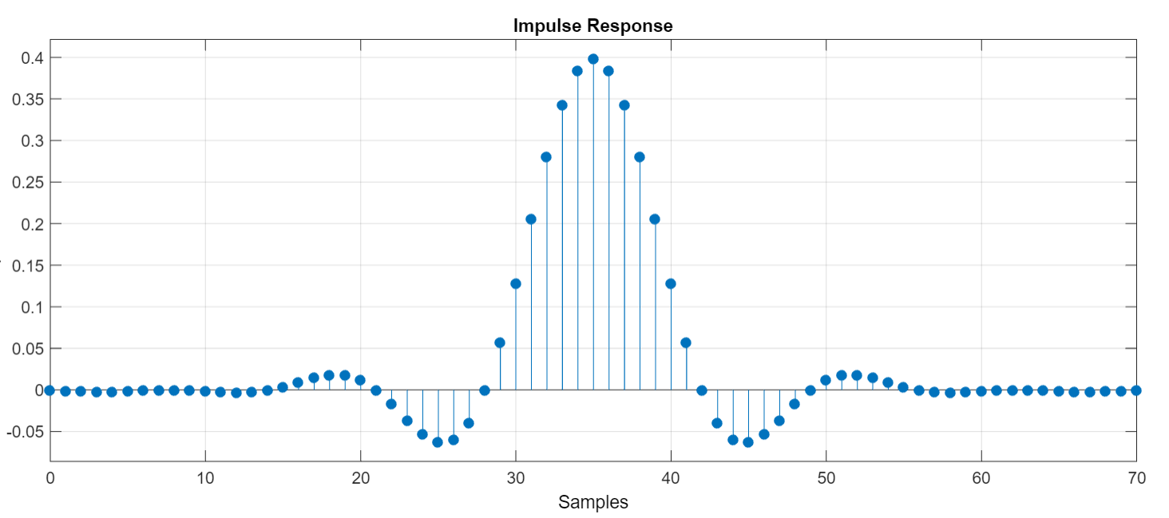

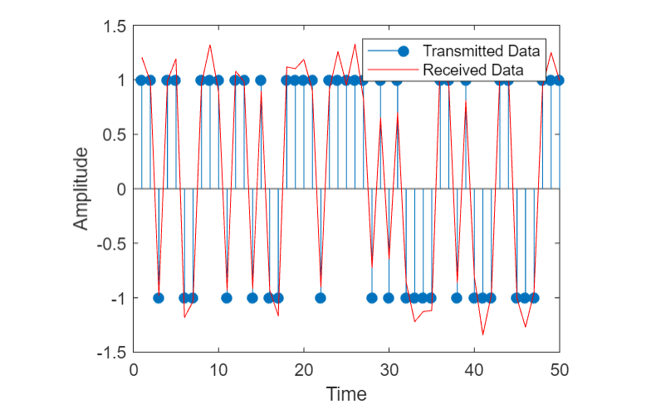

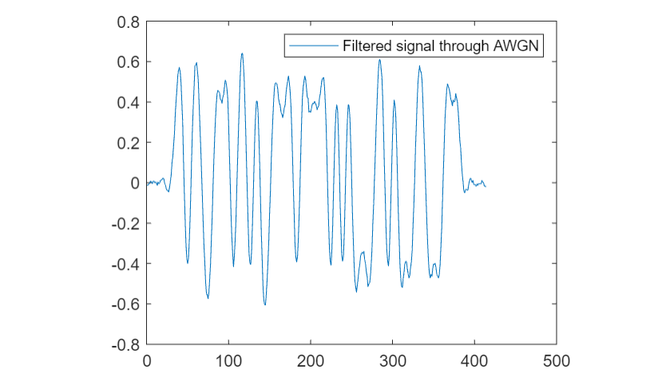

**5.EYE DIAGRAM**

**AIM:**

1. Generate a string of message bits.
2. Use rasied cosine pulse p(t) as the shapig pulse, and generate the corresponding baseband signal with a fixed bit duration Tb. You may use roll-off factor as α = 0.4.
3. Use various roll off factors and plot the eye diagram in each case for the received signal. Make a comparison study among them.

**THEORY:**

In telecommunication, an **eye pattern**, also known as an **eye diagram**, is an oscilloscope display in which a digital signal from a receiver is repetitively sampled and applied to the vertical input, while the data rate is used to trigger the horizontal sweep. It is so called because, for several types of coding, the pattern looks like a series of eyes between a pair of rails. It is a tool for the evaluation of the combined effects of channel noise, dispersion and inter symbol interference on the performance of a baseband pulse-transmission system.

**ALGORITHM:**

1. Generate a string of message bits.
2. Design square root raised cosine filter with roll off factor 0.4
3. Upsample and filter the data for pulse shaping.
4. Convert the ratio of energy per bit to noise power spectral density (EbNo) to an SNR value for use by the awgn function.
5. Filter the signal through an AWGN channel.
6. Downsample and pass the received signal through matched filter.
7. Plot eye diagram for transmitted signal, received signal and filtered signal.

**MATLAB CODE**

% Program for pass a signal through a square-root, raised cosine filter.

% Pulse Shaping and Matched Filtering

close all;

clear;

rolloff = 0.4; % Rolloff factor

span = 10; % Filter span in symbols

sps = 7; % Samples per symbol

M = 16; % Modulation order

k = log2(M); % Bits per symbol

% Generate the square-root, raised cosine filter coefficients.

rctFilt = rcosdesign(rolloff, span, sps,'normal');

fvtool(rctFilt,'Analysis','impulse')

% Create a vector of bipolar data.

BP_Data = 2*randi([0 1], 50, 1) - 1;

% Upsample and filter the data for pulse shaping.

UP_s = upfirdn(BP_Data, rctFilt, sps,1)

% Using the number of bits per symbol (k)

% and the number of samples per symbol (sps),

% convert the ratio of energy per bit to noise power spectral density (EbNo)

% to an SNR value for use by the awgn function.

EbNo = 100;

snr = EbNo + 10*log10(k) - 10*log10(sps);

filtlen = 10; % Filter length in symbols

rxSignal = awgn(UP_s,snr,'measured');% filtering the signal through an AWGN channel.

% Add noise.

rxSignal = rxSignal + randn(size(rxSignal))*.01;

rxFiltSignal = upfirdn(rxSignal,rctFilt,1,sps); % Downsample and filter

rxFiltSignal = rxFiltSignal(filtlen + 1:end - filtlen); % Account for delay

% Plotting the function

figure;

stem(BP_Data,'filled')

hold on

plot(rxFiltSignal,'r')

xlabel('Time'); ylabel('Amplitude');

legend('Transmitted Data','Received Data')

figure;

plot(rxSignal)

legend('Filtered signal through AWGN')

eyediagram(BP_Data,2);legend('Transmitted signal')

eyediagram(rxSignal,2);legend('Recieved signal')

eyediagram(rxFiltSignal,2);legend('Filtered signal')

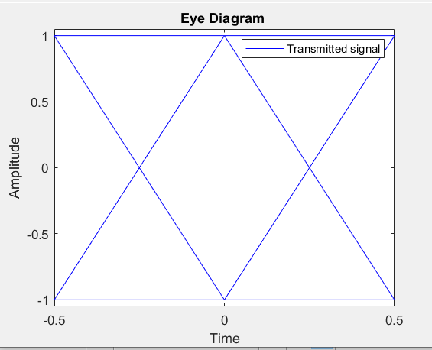

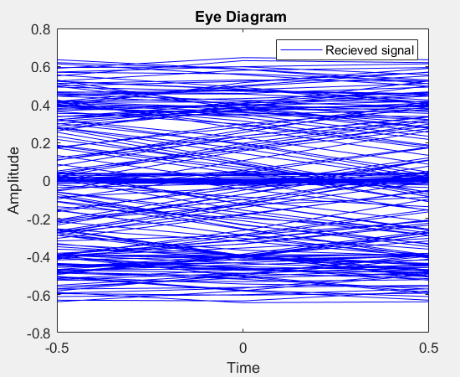

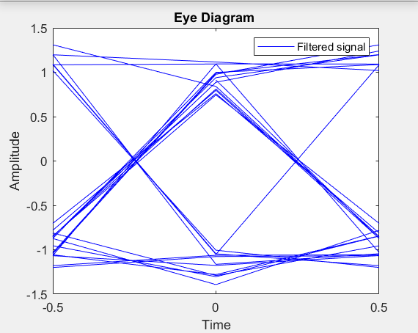

**PART C**

**FAMILIARIZATION WITH SOFTWARE DEFINED RADIO (HARDWARE AND CONTROL SOFTWARE)**

**AIM:**

1.To Familiarize with an SDR hardware for reception and transmission of RFsignal.

2.To Familiarize how it can be interfaced with computer.

3.To Familiarize with GNU Radio (or similar software’s like Simulink/ Lab-View) that can be used to process the signals received through the SDRhardware.

4.To Familiarize available blocks in GNU Radio. Study how signals can begenerated and spectrum (or power spectral density) of signals can beanalyzed. Study how filtering can be performed.

**RTL SDR DONGLE CONNECTION DIAGRAM**

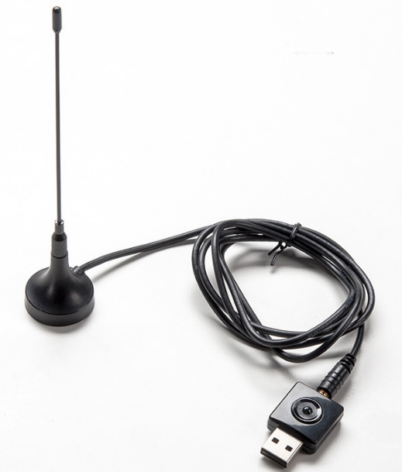

**Inside RTL SDR Dongle**

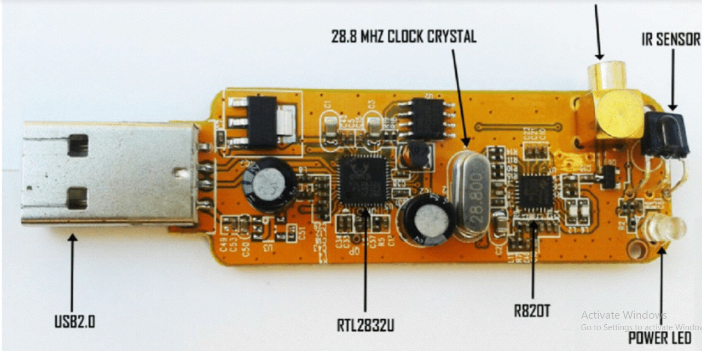

**Block Diagram of SDR Dongle**

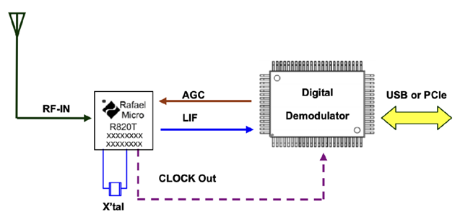

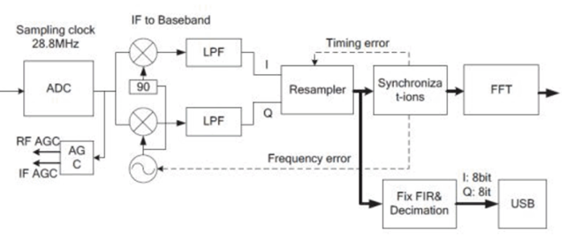

**FM RECEPTION**

**Aim:**

To receive digitized FM signal (for the clearest channel in the lab) using the SDR board.

## SDR# (SDRSharp) Set Up

1. **Go to**[www.airspy.com](http://www.airspy.com/)  **and click on the download button** to download sdrsharp-x86.zip
2. **Extract (unzip) sdrsharp-x86.zip** to a folder
3. **Double click on** **install-rtlsdr.bat** from within the extracted folder. This will start a command prompt that will download all the drivers required to make SDRSharp work with RTL-SDR. The command prompt will automatically close after a few seconds when it is done. It the bat file ran successfully the files rtlsdr.dll and zadig.exe will be downloaded into the SDR# directory.

[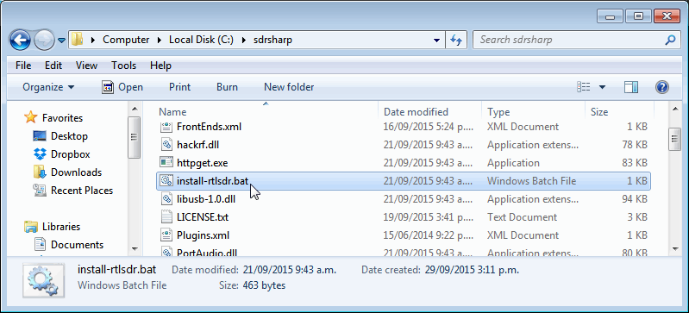](https://www.rtl-sdr.com/wp-content/uploads/2013/04/install-bat_sdrsharp.png)

1. **Plug in SDR dongle**. In the folder where you extracted the sdrsharp files find the file called **zadig.exe**. Right click this file and select "Run as administrator".
2. In Zadig, go to "**Options->List All Devices**" and make sure this option is checked.

[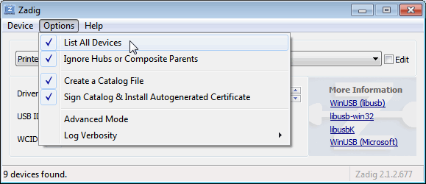](https://www.rtl-sdr.com/wp-content/uploads/2013/04/zadig_1.png)

1. Select "**Bulk-In, Interface (Interface 0)**" from the drop down list.
2. We need to install the WinUSB driver, so also **ensure that WinUSB is selected** in the box after the arrow next to where it says Driver (this is the default selection). The box to the left of the green arrow is not important, and it may show (NONE) or (RTL...). This left hand box indicates the currently installed driver, and the box to the right the driver that will be installed after clicking Replace/Install Driver.

[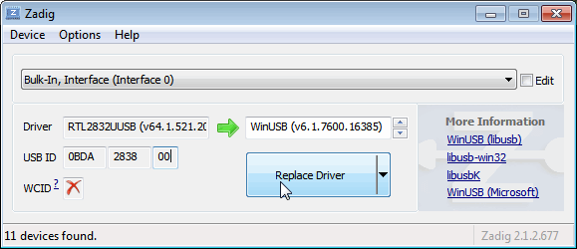](https://www.rtl-sdr.com/wp-content/uploads/2013/04/zadig_3.png)

1. **Click Replace Driver**. On some PC's you might get a warning that the publisher cannot be verified, but just accept it by clicking on "Install this driver software anyway". This will install the drivers necessary to run the dongle as a software defined radio.

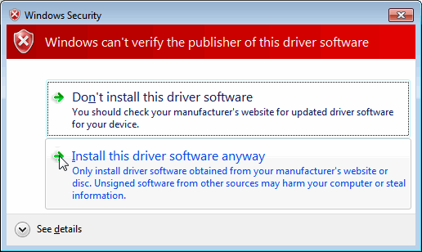

1. **Open SDRSharp.exe and set the "Source" drop down box** **to**'**RTL-SDR USB**'. This "Source" tab is on the lower left menu bar by default.
2. **Press the Play button** (the right facing triangle in the top left of the program).RTL-SDR software radio should now be set up and ready to use.

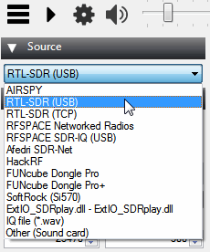

1. Also **adjust the RF gain settings** by pressing the Configure button up the top next to the Play button. By default the RF gain is set at zero. A gain of zero will probably receive nothing but very strong broadcast FM - increase the gain until you start seeing other signals.  
     
   [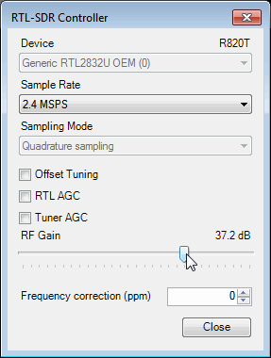](https://www.rtl-sdr.com/wp-content/uploads/2013/04/gain.png)
2. Press Start or alternatively press F2. This will start the SDR.
3. To set the RTL-SDR sample rate, gain and frequency correction click on the ExtIO button .

[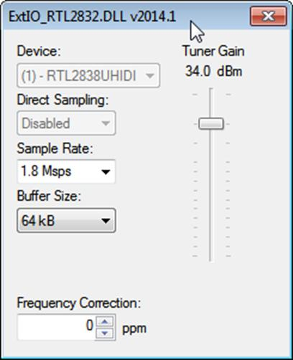](https://www.rtl-sdr.com/wp-content/uploads/2013/04/image023.jpg)

1. To tune to a station, change the Local Oscillator frequency to a frequency near the frequency you are interested in. Then tune to the desired frequency either by clicking in the RF spectrum, or using the Tune numbers.

[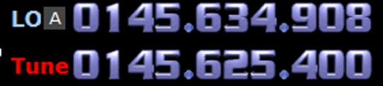](https://www.rtl-sdr.com/wp-content/uploads/2013/04/image024.jpg)

1. You can zoom in and out of the spectrum by using the Zoom slider which is to the left of the word zoom.

[](https://www.rtl-sdr.com/wp-content/uploads/2013/04/image025.jpg)

1. The mode can be altered by clicking on the mode buttons.

[](https://www.rtl-sdr.com/wp-content/uploads/2013/04/image026.jpg)

1. After clicking on the FM mode button, the FM bandwidth can be manually modified with the FM-BW slider.

[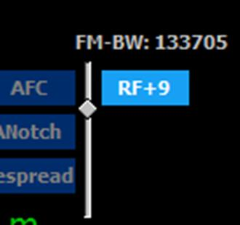](https://www.rtl-sdr.com/wp-content/uploads/2013/04/image027.jpg)

1. To listen to a typical wideband broadcast FM station, you will need to change the audio sampling rate to 192000 Hz. Do this by clicking on the Bandwidth button or alternatively by pressing F6 and then selecting the output sampling rate as 192000 Hz.

# Receiving All India Radio AIR Kannur 101.5 FM

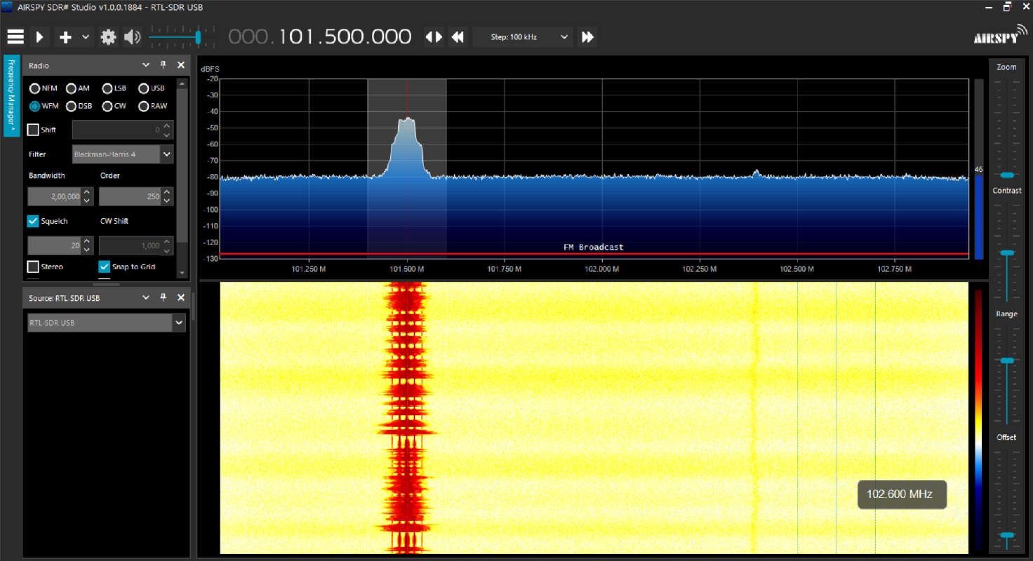

**Familiarize with GNU Radio**

**Aim:**

To familiarize available blocks in GNU Radio. Study how signals can be generated and spectrum (or power spectral density) of signals can be analysed. Study how filtering can be performed.

**GNU Radio**

GNU Radio is a free & open-source software development toolkit that provides signal processing blocks to implement software radios. It can be used with readily-available low-cost external RF hardware to create software-defined radios, or without hardware in a simulation-like environment. It is widely used in research, industry, academia, government, and hobbyist environments to support both wireless communications research and real-world radio systems.

1. Open a terminal window using: Applications > Accessories > Terminal. At the prompt type:

gnuradio-companion.

An untitled GRC window similar to the one below should open.

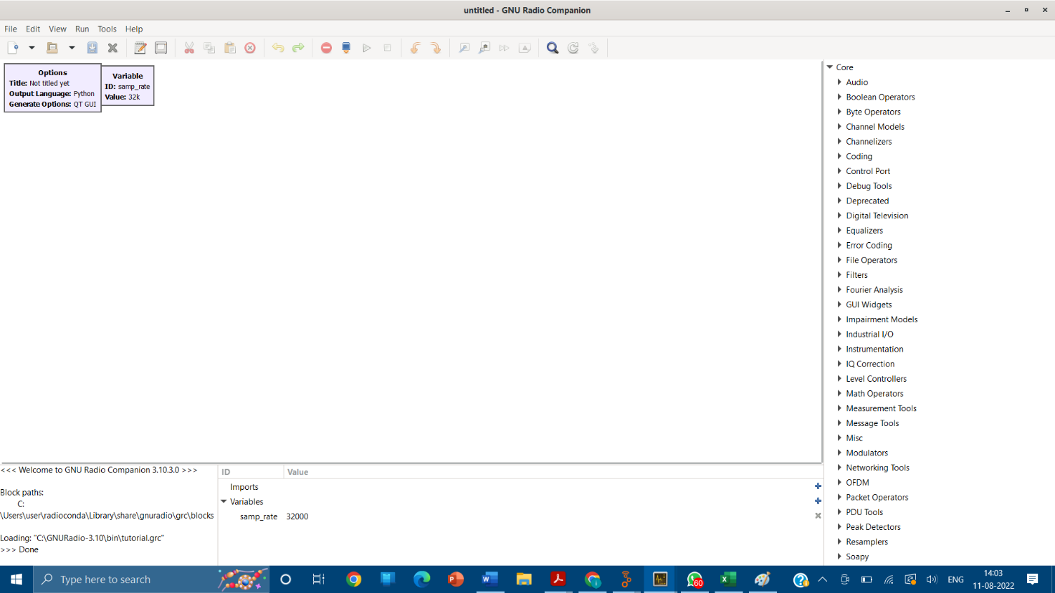

Double click on the Options block. This block sets some general parameters for the flow graph. Type in a project title (such as tutorial) and author. Set Generate Options to QT GUI, Output language to Python. Then close the properties window. The other block that is present is the Variable block. It is used to set the sample rate.



1. On the right side of the window is a list of the blocks that are available. By expanding any of the categories (click on triangle to the left) you can see the blocks available. Explore each of the categories so that you have an idea of what is available.
2. Open the Waveform generators category and double click on the Signal Source. Note that a Signal Source block will now appear in the main window. Double click on the block and the properties window will open. Adjust the settings to match those as shown in the figure below and close the window. This Signal Source is now set to output a real valued 1KHzsinusoid with an amplitude of .5. Change the output type to float.

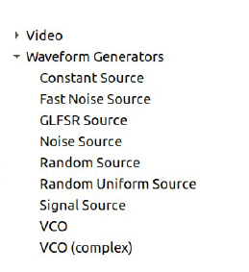

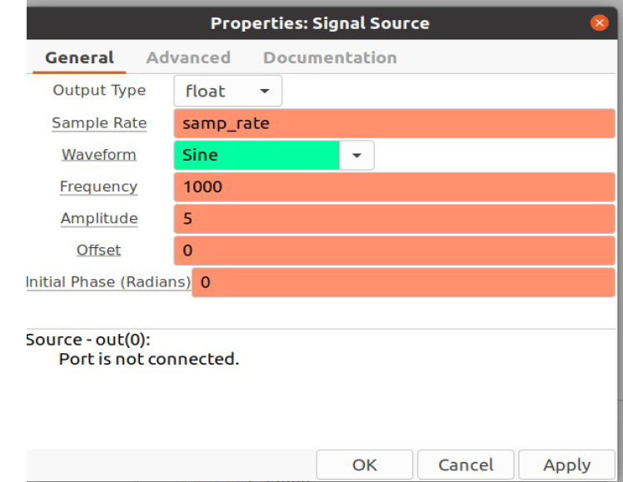

1. In order to view this wave we need one of the graphical sinks. Choose

Core→Instrumentation→ QT →QT GUI Time sink and then double click on it



1. Change the type to float. This sink will act as an oscilloscope. If you want multiple channel, increase the number of inputs to 2.



1. In order to connect these two blocks, click once on the “out” port of the Signal Source, and then once on the “in” port of the Scope Sink. The following flow graph should be displayed.



1. In order to observe the operation of this simple system we must generate the flow graph and then execute it. Click first on the “Generate the flow graph” icon. A box will come up in which you enter the name of the file. Name this file: tutorial1.grc and save. Click the “Execute the flow graph” icon. A scope plot should open displaying several cycles of the sinusoid.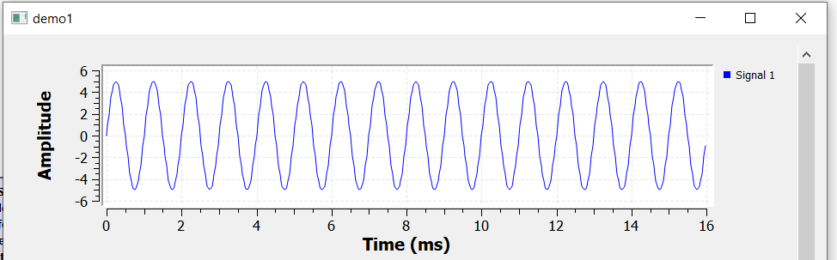
2. Go back to QT GUI sink properties and switch on control panel under config Re run the flow graph

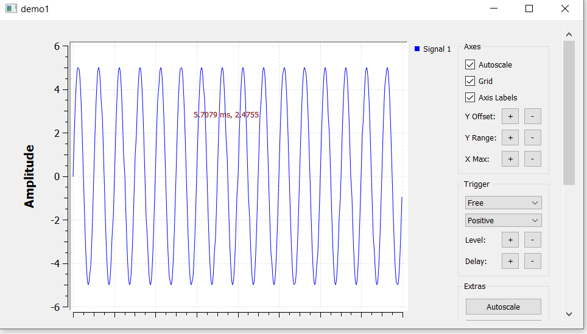

1. Add QT GUI frequency sink . Change the Type to Float and show control panel and leave the remaining parameters at their default values.
2. Connect this to the output of the Signal Source by clicking on the out port of the Signal Source and then the in port of the QT GUI Sink. Generate and execute the flow graph. You should observe the scope as before along with an FFT plot correctly showing the frequency of the input at 1KHz. Close the output windows.

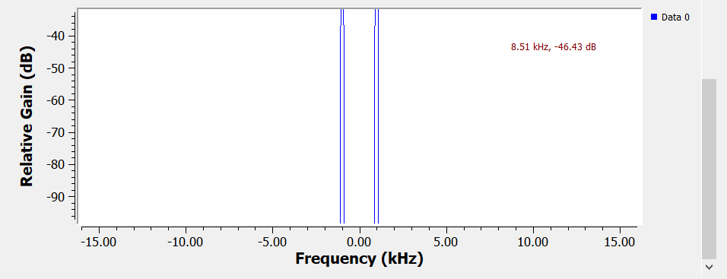

1. Now bring in an Audio sink. Create the flow graph shown below. The Audio Sink is found in Core->Audio -> Audio Sinks category. Generate and execute the flow graph. Along with graphical display of the signal you can hear the 1KHz tone.



1. Construct the flow graph shown below. Set the sample rate to 32000. The two Signal Sources should have frequencies of 1000 and 800, respectively. The Add block is found in the Math Operators category.

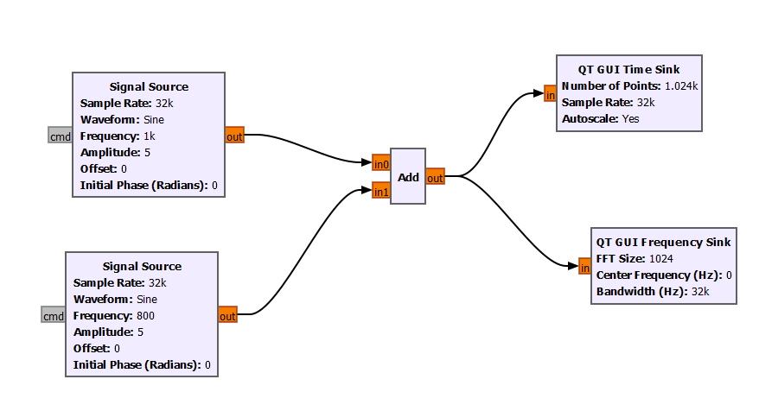

1. Generate and execute the flow graph. On the Scope plot you should observe a waveform corresponding to the sum of two sinusoids. On the FFT plot you should see components at both 800 and 1000 Hz.

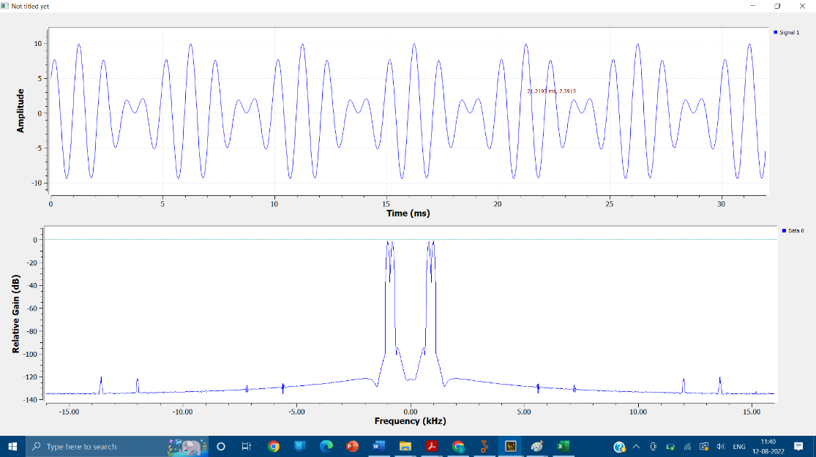

1. Replace the Add block with a Multiply block.

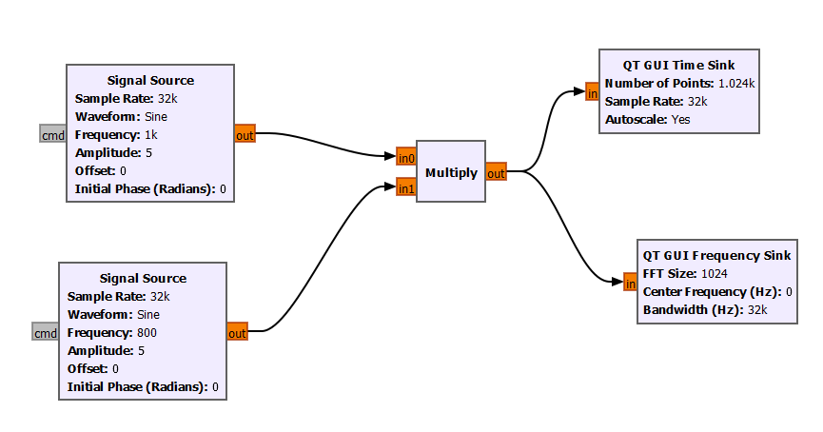



1. Modify the flow graph to include a Low Pass Filter block as shown in the figure below. This block is found in the Core→ Filters category. Multiply block outputs a 200Hz and a 1.8KHz sinusoid. We want to create a filter that will pass the 200Hz and block the 1.8KHz component. Set the low pass filter to have a cutoff frequency of 1KHz and a transition width of 200 Hz. Use a Rectangular Window. Generate and execute the flow graph. Only the 200Hz component passes through the filter.

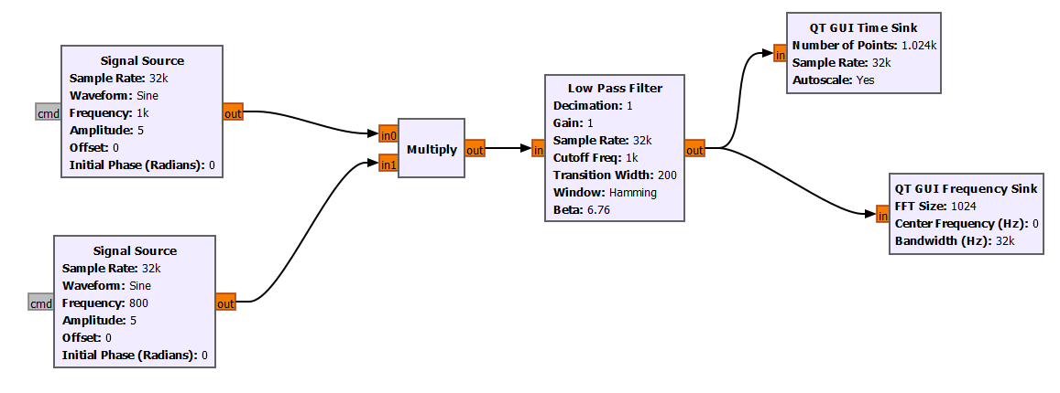

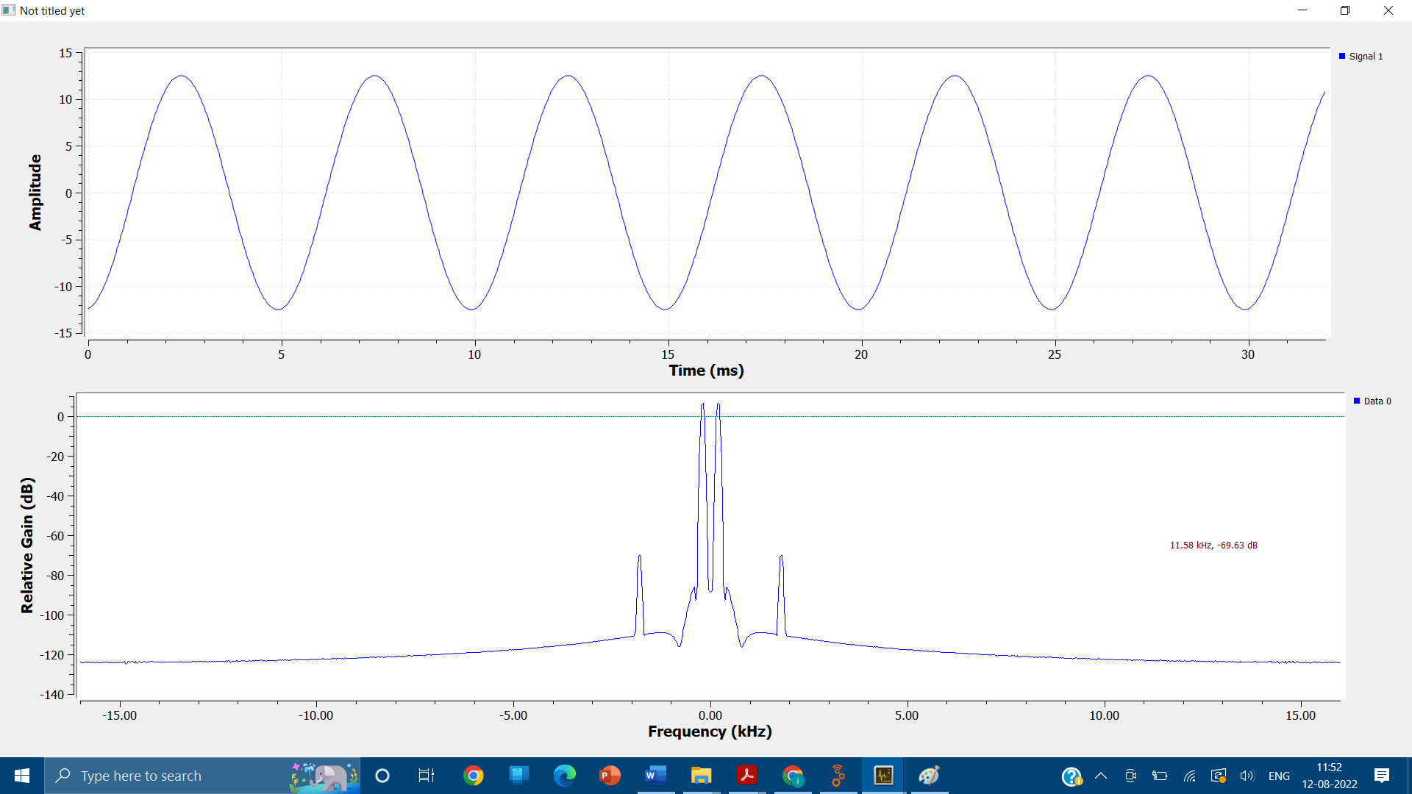

RTL-SDR for RF Signal Capture on GNU Radio

